Analyzing Photographs
Student’s Name
Institution Affiliation

Analyzing Photographs
Image 1
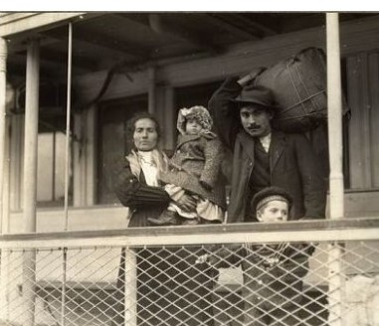
The photo shows an immigrant family. They either have just arrived or are about to leave their home. The children do not seem to understand the troubles their parents have gone through. Yet, in the United States, the number of immigrants and their descendants who have become economy drivers have grown tremendously. This photograph probably shows the state in which immigrants were and comparing it to today, a huge change can be confessed.
Image 2
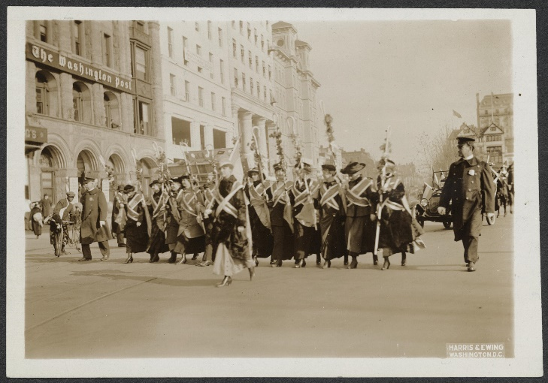
The photograph represents women marching in uniform. These women must be fighting for certain rights, most probably equality rights. Their marching shows that they feel equal to men and should be treated equally. Beside them, policemen accompany them probably to ensure that the marching is peaceful and democratic. This photograph reminds us of the women’s fight for their rights to vote.
Image 3
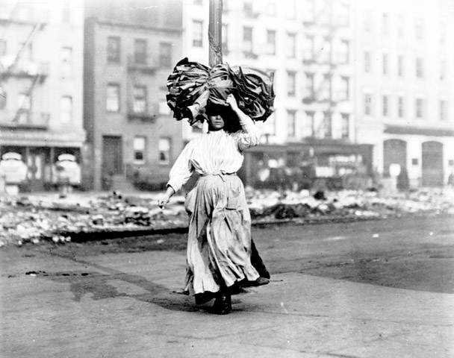
The photograph captures a young girl carrying a bundle of cloths most probably on her way home. She must be taking them home to ensure that they are sewn before the following day. This photograph indicates the overworking that the employees of the Triangle factory had to endure to acquire salaries. The deadly 1911 fire that caused so many workers to die added to the pain that poor immigrants were going through. Despite the poor working conditions, these workers had to work hard, even taking their work home, top ensure they did not lose their jobs.

Image 4
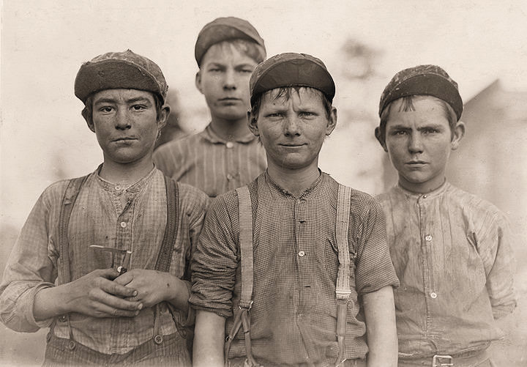
The picture shows four boys whose faces may not spell out their age. They look worn out and shabby, most probably from an exhausting day at work. Their expressions are of absolute indifference, perhaps because their only option is to work in the factories. These adolescent boys have been deprived of the joy of their youth. The wrinkles on their faces and the indecent clothes spells out child exploitation that was so rampant in the industrialization era.
Websites
#1 https://www.tenement.org/explore/immigration-in-america/
#2 http://memory.loc.gov/ammem/index.html
#3 http://trianglefire.ilr.cornell.edu/
#4 https://www.historyplace.com/index.html

